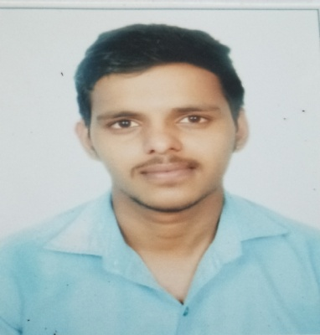

DINESH CHAUDHARI

# Arrow Slight curvePersonal Info

Date of Birth: 11-March-1997

**Nationality**: Indian

Address: Room no:1, Shreevastav chawl, Rawalpada, Dahisar (East) Mumbai 400 068.

Phone: 7678053516

Email address: [chaudharidinesh538@gmail.com](mailto:chaudharidinesh538@gmail.com)

Language Known: English, Hindi, Marathi & Rajasthani.

# Arrow Slight curve Education

**Bachelor of Electronics & Telecommunication Engineering**: Jul’15 to Jul’19 Xavier Institute of Engineering, (Mumbai University). Achieved with 6.55 Cgpi

**Higher School Certificate**: Jul’13 to Jul’15

Sardar vallabhbhai patel Jr college, Mumbai. Achieved distinction with 61.63%.

**Secondary School Certificate**: Jun’12 to Jun’13

Shree Vishwakarma High School, Mumbai. Achieved distinction with 80.18%.

# Arrow Slight curveProject

**DCR: Devanagri Character Recoginition Using Image Processing.**

# Arrow Slight curveWork Experience

# **Toppers Technology private ltd**

# Roles & Responsibilities- Academic Consultant

# 

IT Proficiency

Arrow Slight curve

**Programming Languages:**

**HTML, CSS, Javascript, React.js, Node.js**

Java (Good Knowledge of OOPS)

Good Knowledge of Object and class.

Good Knowledge about Inheritance, Polymorphism and Encapsulation

**Database: MYSQL**

Good Knowledge **in DDL, DML, DCL.**

Good Knowledge of Joins and Functions.

# Arrow Slight curve CO-/Extra-Curricular Activities

## Conducted Various Events in the fest of XIE.

## Contributed to XIE Logistics Team During “SPANDAN” 2017.

# Arrow Slight curveStrengths



Adaptable



# HArrow Slight curveobbies

